**A REPORT ON DATABASE MANAGEMENT SYSTEM OF**

**SOUTH EAST BANK LIMITED**

**Course title: Database Systems Project / Fieldwork**

**Course No.: CSE 3102**

**Submitted By:**

Khandker M. Qaiduzzaman

ID: 110229

Rezoana Ahmed

ID: 110234

Somapti Mondal

ID: 110251

**Submitted To:**

Dr. Md. Anisur Rahman

Professor

CSE Discipline

Khulna Univesity

Md. Zahidul Islam

Assistant Professor

CSE Discipline

Khulna University

Khulna University

Date of Submission: November 3, 2013

**Relational Table:**

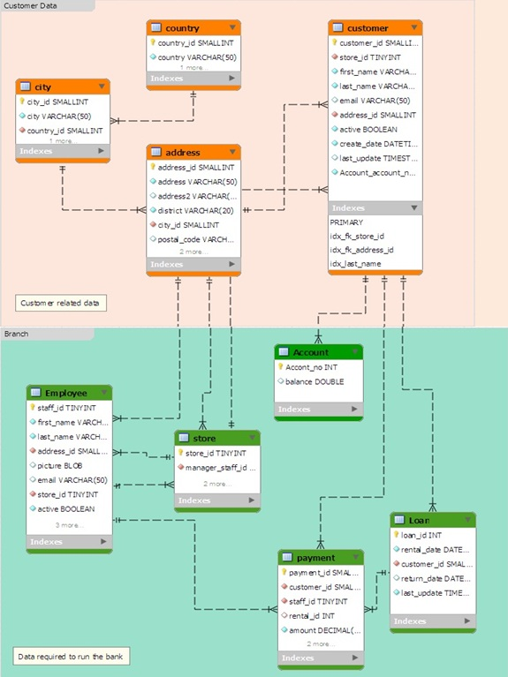

Query:

* Find the Bank Identity according to its Code, name and license no.
* Select Branch details from Branch Table Like Branch Name, Address and asset
* Select Branch details like branch current balance according to the customer account no.
* Select the Loan details from loan Table. Just like loan present update according to the customer account no. And rate of interest.
* Select the payment details from the payment Table where customer pays the loan installment, also know about payment time and date.
* Select Customer details From Customer Table just like Customer id, National ID, Address
* Select Employee details from Employee table just like Name, Department Name, Phone Number, employment length.

Another Query:

Select Loan start date and end date from loan table according to our date modification.